
Fuhua-Parallel Sec 3 Express EOY 2026 Paper 1 — Marking Scheme
Worked Solutions + Marking Scheme
Cambridge Learning Group · Fuhua-parallel practice paper · Paper 1 · 2026
14 pages · 80 marks

How to read this booklet:
BLACK — the question, written ON the original question paper
BLUE — the full step-by-step working and the reason for each line
RED — the marking scheme: where each B1 / M1 / A1 is earned, the traps,
and the key concept the question is testing

Mark codes: B1 independent answer mark · M1 method mark (earned even if
the answer is wrong) · A1 accuracy mark (only if the method mark was earned).

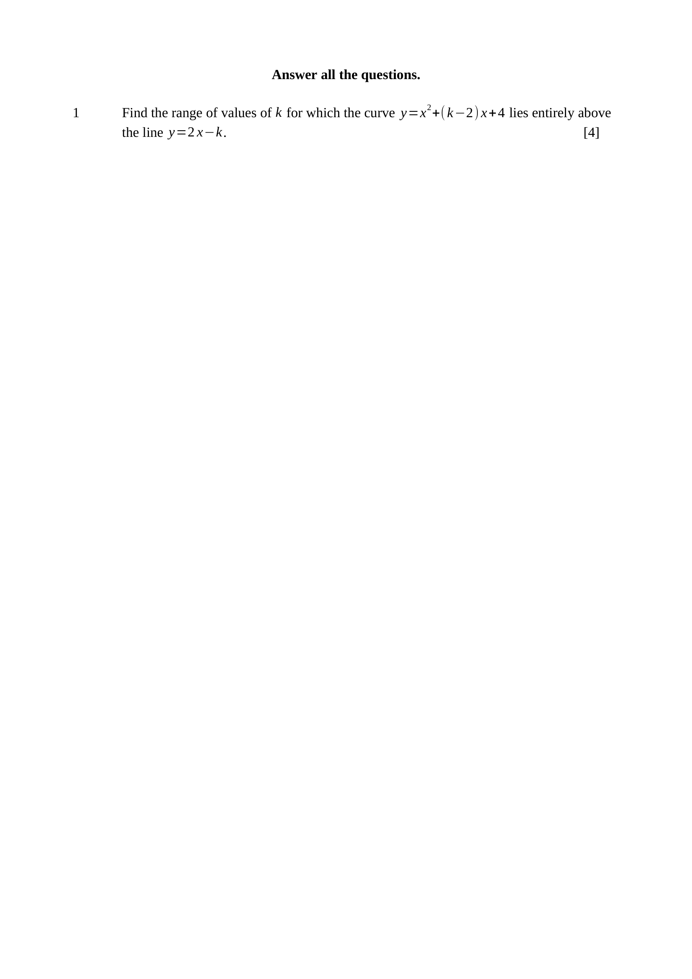
Curve above line for all $x$:
$x^{2}+(k−2)x+4>2x−k$ for all $x$
$x^{2}+(k−4)x+(4+k)>0$ for all $x$
A positive quadratic is always above the $x$-axis when it has no real root:
$(k−4)^{2}−4(4+k)<0$
$k^{2}−8k+16−16−4k<0$
$k^{2}−12k<0$
$k(k−12)<0$
$∴0<k<12$
Key concept: above for ALL $x$ means the difference is a positive quadratic with no real root.
M1 – forms the difference and gets $x^{2}+(k−4)x+(4+k)>0$
M1 – uses $\text{discriminant}<0$ (not $≤0$, and not $0<\text{discriminant}$)
M1 – reduces to $k^{2}−12k<0$
A1 – $0<k<12$
Trap – $k<0$ or $k>12$ comes from solving $k(k−12)>0$; sketch the parabola in $k$.

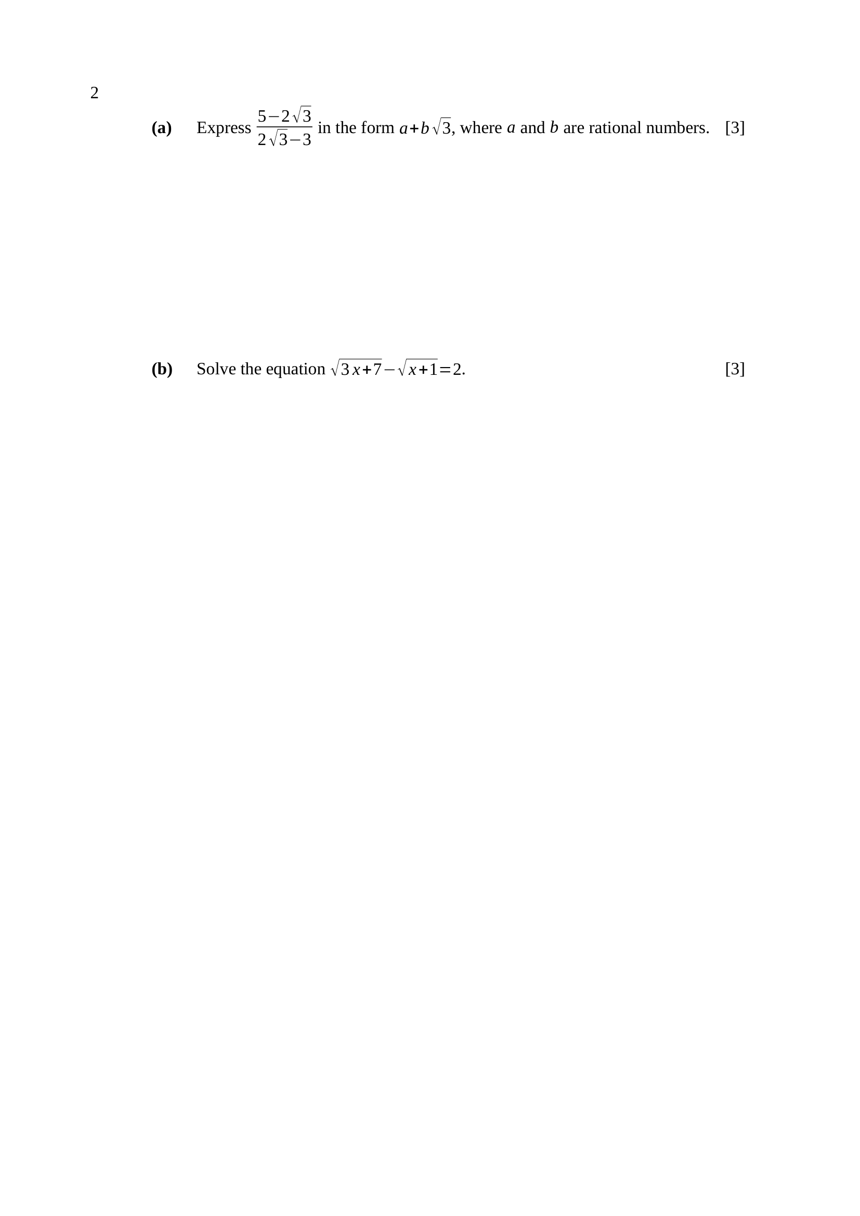
$\frac{5−2\sqrt{3}}{2\sqrt{3}−3}×\frac{2\sqrt{3}+3}{2\sqrt{3}+3}$
$\text{denominator}={\left(2\sqrt{3}\right)}^{2}−3^{2}=12−9=3$
$\text{numerator}=10\sqrt{3}+15−4(3)−6\sqrt{3}$
$\text{numerator}=4\sqrt{3}+3$
$\frac{3+4\sqrt{3}}{3}=1+\frac{4}{3}\sqrt{3}$
$∴a=1, b=\frac{4}{3}$
Key concept: the conjugate of $2\sqrt{3}−3$ is $2\sqrt{3}+3$.
M1 – multiplies by the conjugate $2\sqrt{3}+3$
M1 – denominator $12−9=3$
A1 – $a=1$ and $b=\frac{4}{3}$
Note – the question says RATIONAL, not integer — $\frac{4}{3}$ is acceptable.
$\sqrt{3x+7}=2+\sqrt{x+1}$
$3x+7=4+4\sqrt{x+1}+x+1$
$2x+2=4\sqrt{x+1}$
$x+1=2\sqrt{x+1}$
let $w=\sqrt{x+1}$: $w^{2}=2w$
$w(w−2)=0$, so $w=0$ or $w=2$
$x+1=0$ or $x+1=4$
check $x=−1$: $\sqrt{4}−\sqrt{0}=2$ ✓
check $x=3$: $\sqrt{16}−\sqrt{4}=4−2=2$ ✓
$∴x=−1$ or $x=3$
Key concept: isolate one surd, square, then isolate the surd that remains.
M1 – squares after isolating one surd
M1 – reaches $x+1=2\sqrt{x+1}$ and squares again
A1 – BOTH $x=−1$ and $x=3$
Trap – both roots satisfy the original equation — neither may be rejected. Discarding one loses the A1.

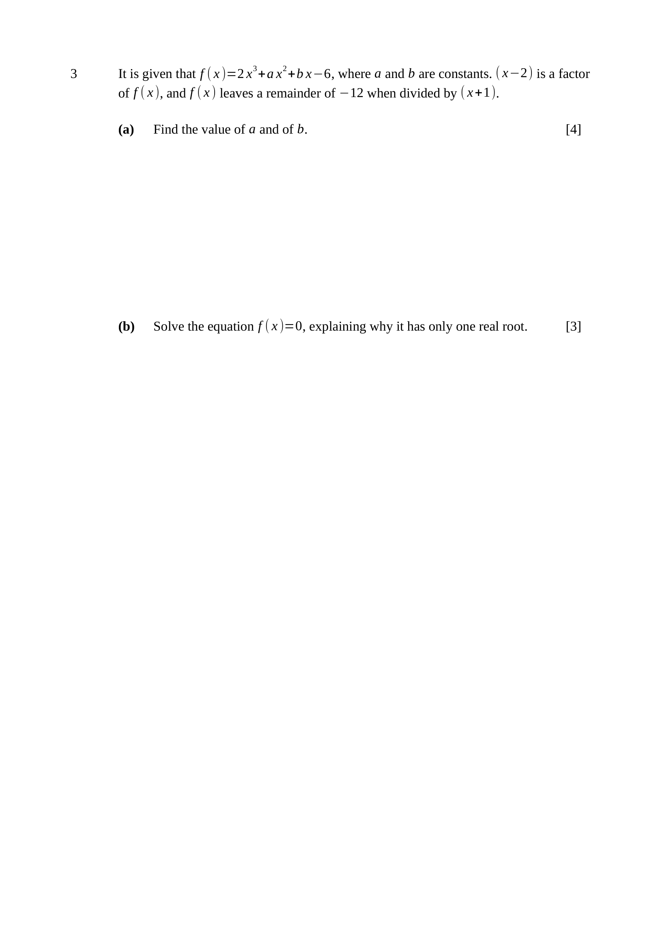
$\left(x − 2\right)$ a factor $⇒f(2)=0$:
$16+4a+2b−6=0$
$2a+b=−5$ …(1)
$f(−1)=−12$: $−2+a−b−6=−12$
$a−b=−4$ …(2)
(1)+(2): $3a=−9$, so $a=−3$
from (2): $b=a+4=1$
$∴a=−3, b=1$
M1 – $f(2)=0$ used
A1 – $2a+b=−5$
M1 – $f(−1)=−12$ used
A1 – $a=−3$ and $b=1$
Trap – remainder $−12$ means $f(−1)=−12$, not $f(−1)=0$.
$f(x)=2x^{3}−3x^{2}+x−6$
$f(x)=(x−2)\left(2x^{2} + x + 3\right)$
$x−2=0$ gives $x=2$
for $2x^{2}+x+3=0$:
$\text{discriminant}=1^{2}−4(2)(3)=1−24=−23<0$
so the quadratic factor has no real root
$∴x=2$ is the only real root
Key concept: a cubic with one real root has an irreducible quadratic factor.
M1 – divides out $\left(x − 2\right)$ to get $2x^{2}+x+3$
A1 – discriminant $−23<0$ computed
A1 – states $x=2$ is the only real root, because the quadratic has no real root
Note – the explanation is required — quoting $x=2$ alone scores at most M1 A1.

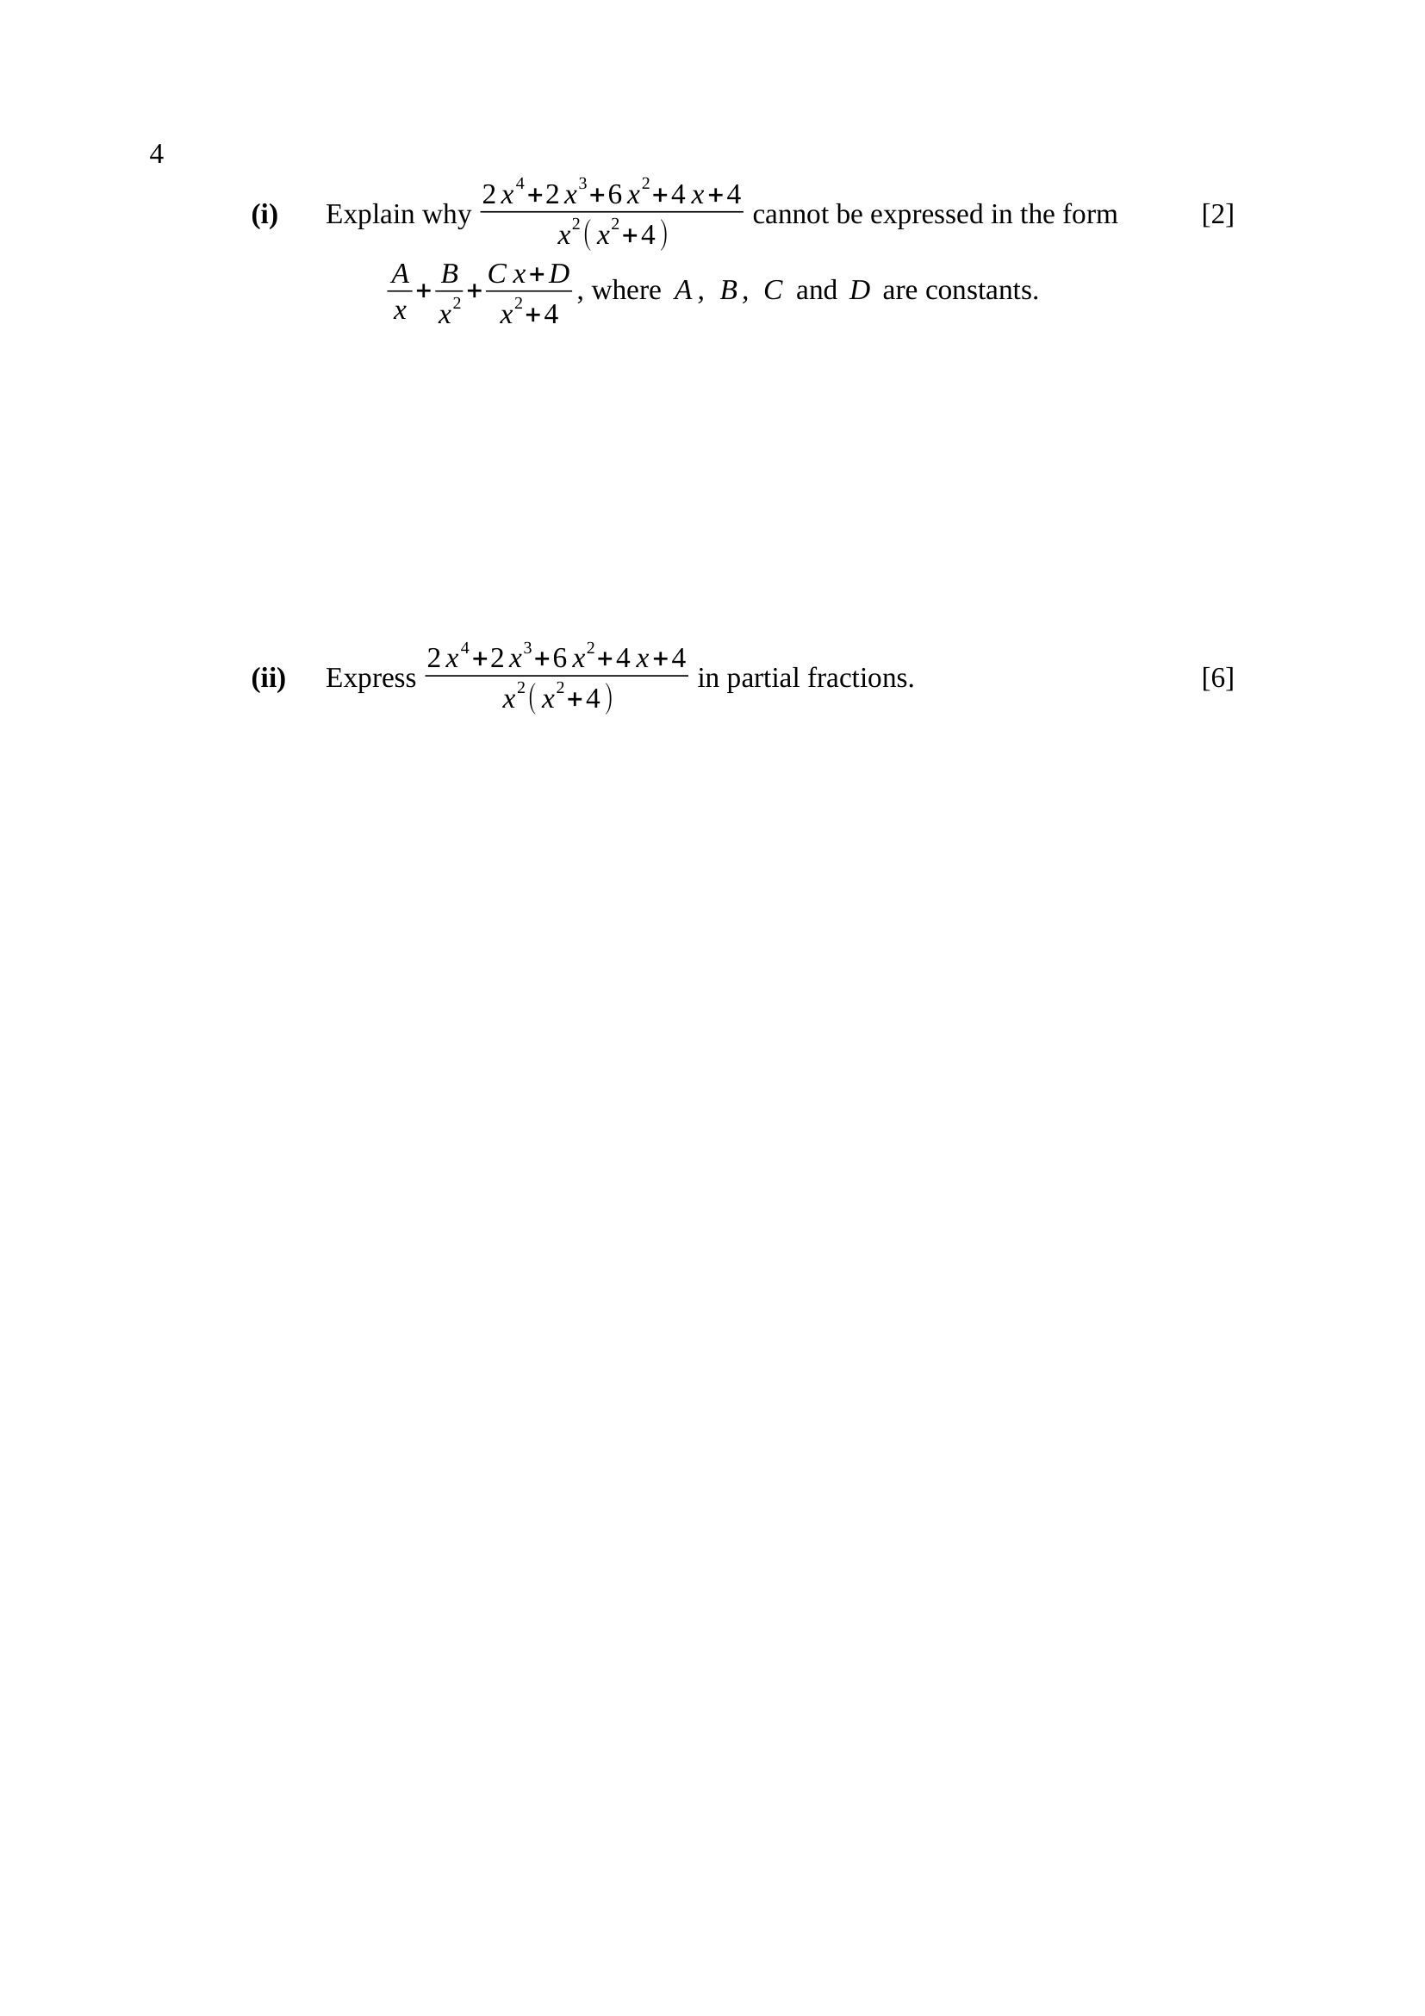
Numerator $\text{degree}=4$; denominator $x^{2}\left(x^{2} + 4\right)$ has degree $4$.
The fraction is improper (degree of top $≥$ degree of bottom).
The given form is a sum of proper fractions, so it can only represent a proper fraction.
A constant term must be included first, by division.
B1 – identifies both degrees as $4$, so the fraction is improper
B1 – states that a constant (the quotient) is needed before the proper fractions
Note – saying only “the powers are the same” without the conclusion scores B1.
$\frac{2x^{4}+2x^{3}+6x^{2}+4x+4}{x^{4}+4x^{2}}=2+\frac{2x^{3}−2x^{2}+4x+4}{x^{2}\left(x^{2} + 4\right)}$
$\frac{2x^{3}−2x^{2}+4x+4}{x^{2}\left(x^{2} + 4\right)}=\frac{A}{x}+\frac{B}{x^{2}}+\frac{Cx+D}{x^{2}+4}$
$2x^{3}−2x^{2}+4x+4=Ax\left(x^{2} + 4\right)+B\left(x^{2} + 4\right)+(Cx+D)x^{2}$
$x=0$: $4=4B$, so $B=1$
$x^{3}$: $2=A+C$; $x^{2}$: $−2=B+D$, so $D=−3$
$x$: $4=4A$, so $A=1$, hence $C=1$
$∴2+\frac{1}{x}+\frac{1}{x^{2}}+\frac{x−3}{x^{2}+4}$
Key concept: divide first, then split; $x^{2}$ needs TWO terms and $x^{2}+4$ needs $Cx+D$.
M1 – divides to get the quotient $2$
M1 – correct form with $\frac{A}{x}+\frac{B}{x^{2}}+\frac{Cx+D}{x^{2}+4}$
M1 – clears denominators and substitutes or compares
A1 – $B=1$ and $A=1$
A1 – $C=1$
A1 – $D=−3$
Note – check at $x=1$: $\text{LHS}=\frac{18}{5}$, $\text{RHS}=2+1+1−\frac{2}{5}=\frac{18}{5}$ ✓

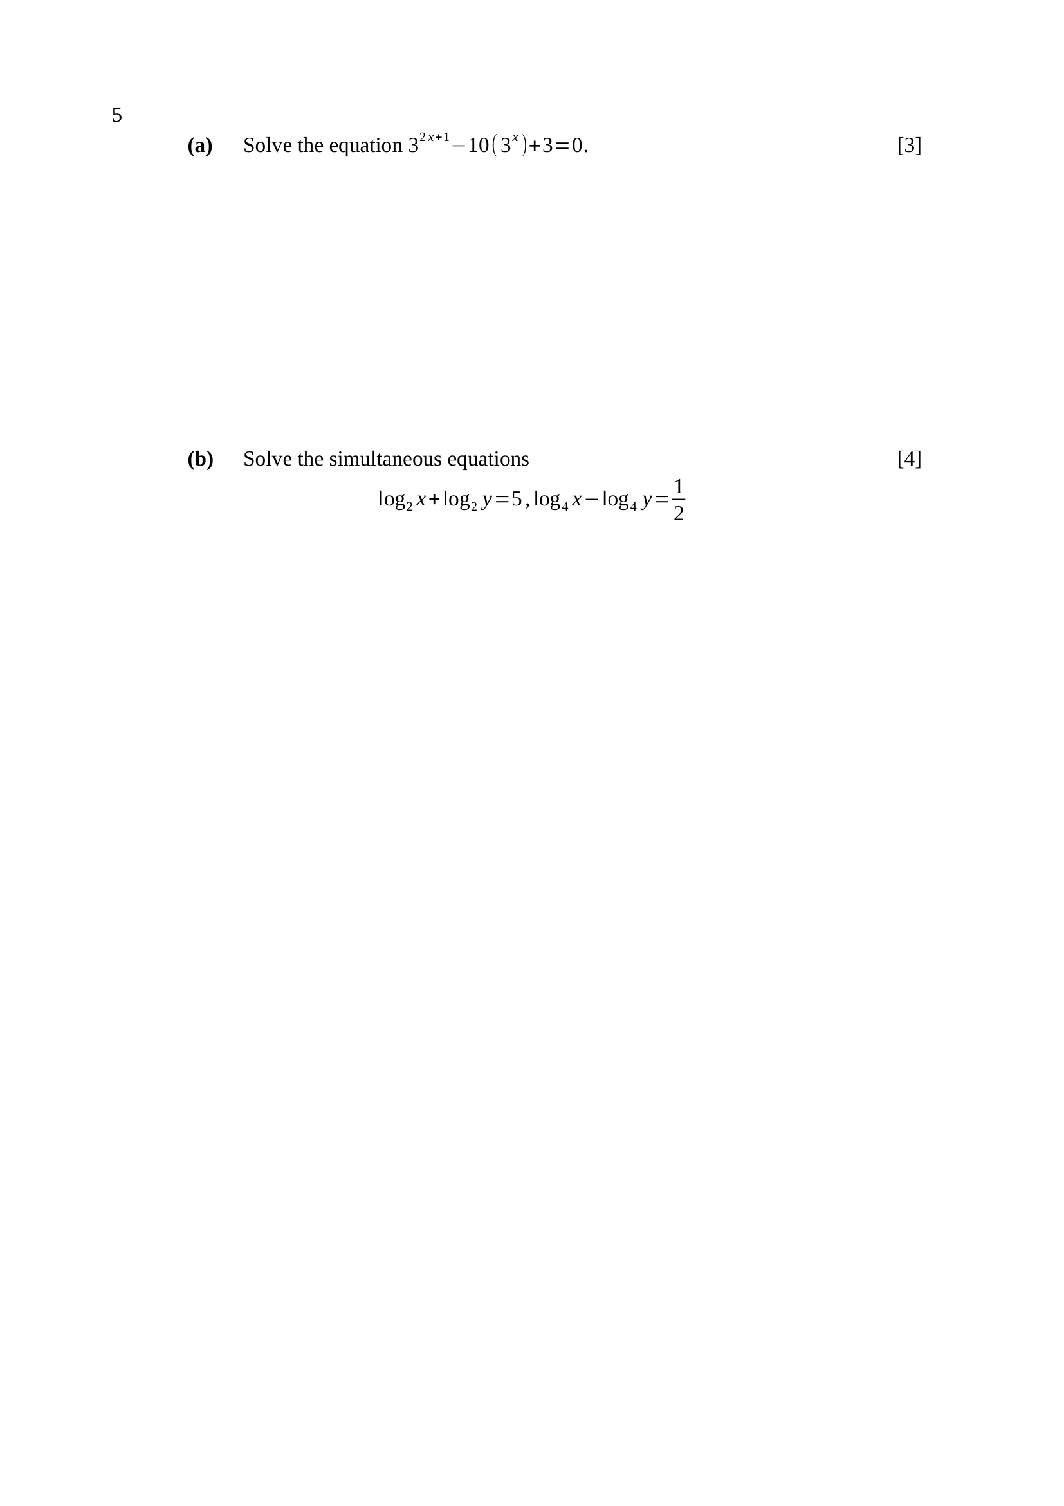
$3^{ 2x+1}=3{\left(3^{ x}\right)}^{2}$
let $u=3^{ x}$: $3u^{2}−10u+3=0$
$(3u−1)(u−3)=0$
$u=\frac{1}{3}$ or $u=3$
$3^{ x}=3^{−1}$ or $3^{ x}=3^{1}$
$∴x=−1$ or $x=1$
Key concept: $3^{2x+1}=3·{\left(3^{x}\right)}^{2}$ turns it into a quadratic.
M1 – writes $3^{ 2x+1}$ as $3{\left(3^{ x}\right)}^{2}$ and substitutes $u=3^{ x}$
M1 – solves the quadratic in $u$
A1 – $x=−1$ and $x=1$
Trap – $3^{ 2x+1}≠{\left(3^{ x}\right)}^{2}$ — the extra factor of $3$ is what makes it work.
$\log_{2}x+\log_{2}y=5⇒\log_{2}(xy)=5$
$xy=32$ …(1)
$\log_{4}x−\log_{4}y=\frac{1}{2}⇒\log_{4}\frac{x}{y}=\frac{1}{2}$
$\frac{x}{y}=4^{\frac{1}{2}}=2$, so $x=2y$ …(2)
(2) into (1): $2y^{2}=32$
$y^{2}=16$, and $y>0$, so $y=4$
$∴x=8, y=4$
Key concept: combine each equation into a single log, then remove the log.
M1 – $\log_{2}(xy)=5$ giving $xy=32$
M1 – $\log_{4}\frac{x}{y}=\frac{1}{2}$ giving $\frac{x}{y}=2$
A1 – $y=4$
A1 – $x=8$
Trap – $y=−4$ must be rejected: $\log_{2}y$ requires $y>0$.

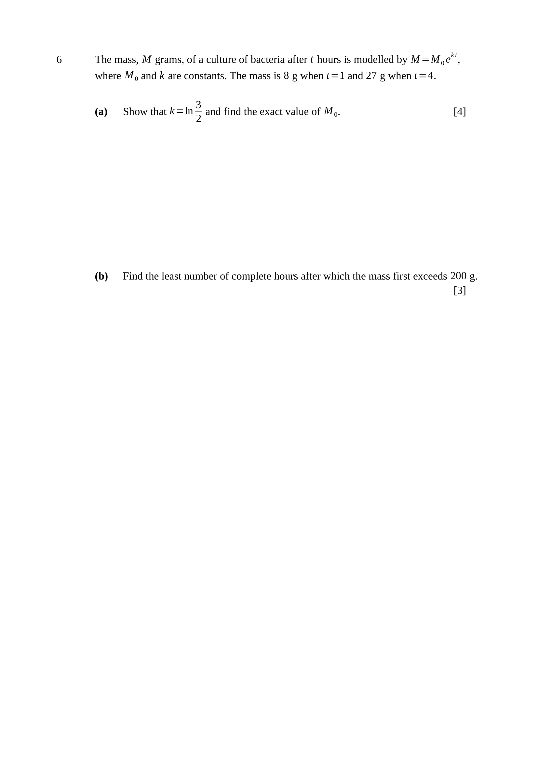
$t=1$: $8=M_{0}e^{ k}$; $t=4$: $27=M_{0}e^{ 4k}$
dividing: $\frac{27}{8}=e^{ 3k}$
$3k=ln\frac{27}{8}=3ln\frac{3}{2}$
$∴k=ln\frac{3}{2}$ (shown)
$e^{ k}=\frac{3}{2}$, so $8=M_{0}\left(\frac{3}{2}\right)$
$∴M_{0}=\frac{16}{3}$ g
Key concept: divide the two equations to eliminate $M_{0}$.
M1 – both equations written and divided
M1 – $e^{ 3k}=\frac{27}{8}$
A1 – $k=ln\frac{3}{2}$ shown, using $ln\frac{27}{8}=3ln\frac{3}{2}$
A1 – $M_{0}=\frac{16}{3}$
Note – exact value required — $5.33$ alone loses the A1.
$\frac{16}{3}{\left(\frac{3}{2}\right)}^{t}>200$
${\left(\frac{3}{2}\right)}^{t}>\frac{600}{16}=37.5$
$tln\frac{3}{2}>ln37.5$
$t>\frac{3.6243}{0.40546}=8.938…$
$∴$ the least number of complete hours is $9$
M1 – forms the inequality and isolates ${\left(\frac{3}{2}\right)}^{t}$
M1 – takes logs correctly
A1 – $9$ hours
Trap – $t=8.94$ rounds to $8.9$, but the mass has not yet exceeded $200$ g at $t=8$ — the answer is the next whole hour, $9$.

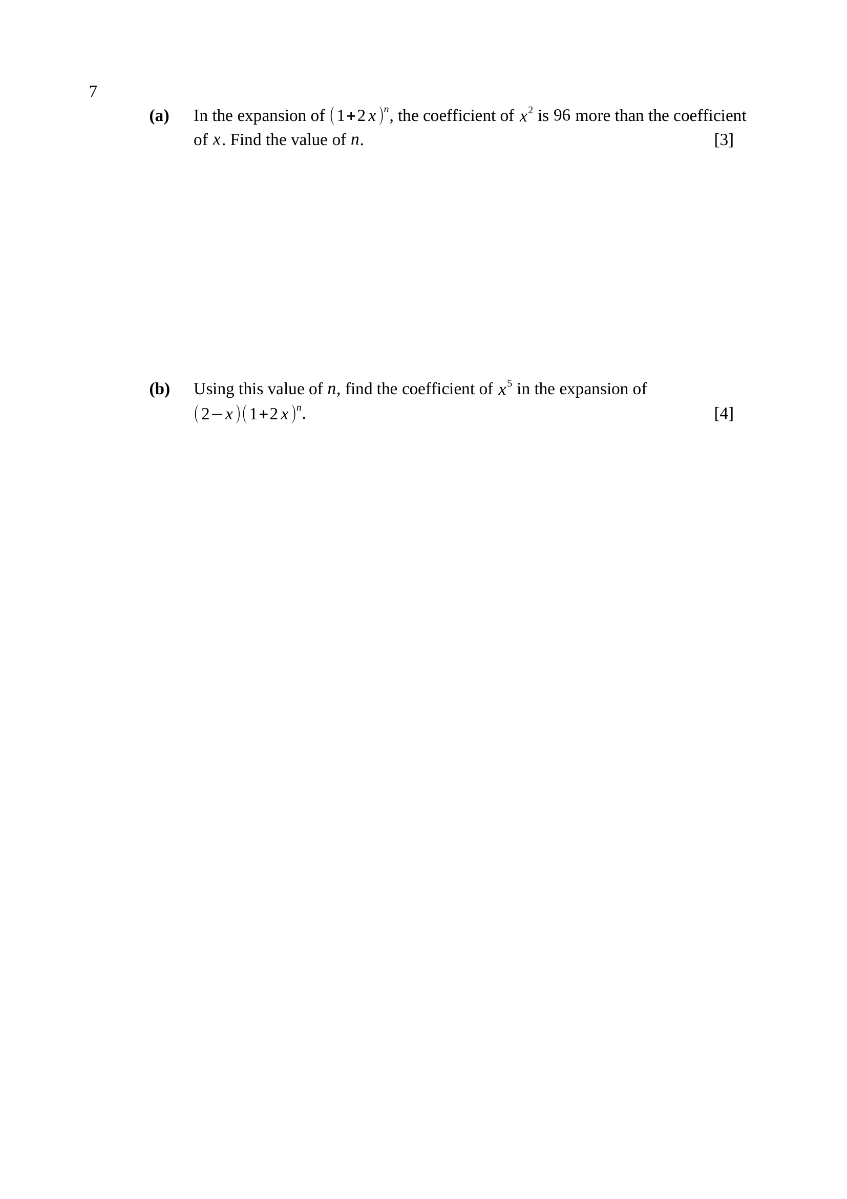
coefficient of $x$: $({n \atop 1})2=2n$
coefficient of $x^{2}$: $\left({n \atop 2})2^{2}=2n(n−1\right)$
$2n(n−1)=2n+96$
$2n^{2}−4n−96=0$
$n^{2}−2n−48=0$
$(n−8)(n+6)=0$
$n>0$, so $∴n=8$
M1 – both coefficients written in terms of $n$
M1 – forms $2n(n−1)=2n+96$ and reduces to a quadratic
A1 – $n=8$, rejecting $n=−6$
Trap – $\left({n \atop 2}\right)$ must carry the factor $2^{2}$ from ${\left(2x\right)}^{2}$.
${\left(1+2x\right)}^{8}$: coefficient of $x^{5}=({8 \atop 5})2^{5}=56(32)=1792$
coefficient of $x^{4}=({8 \atop 4})2^{4}=70(16)=1120$
In $\left(2 − x\right){\left(1 + 2x\right)}^{8}$ the $x^{5}$ term comes from
$2×\left(x^{5}\text{ term}\right)$ and $(−x)×\left(x^{4}\text{ term}\right)$
$\text{coefficient}=2(1792)−1(1120)$
$\text{coefficient}=3584−1120$
$∴$ coefficient of $x^{5}=2464$
Key concept: with a bracket in front, TWO terms of the expansion contribute.
M1 – coefficient of $x^{5}$ in ${\left(1+2x\right)}^{8}$ as $({8 \atop 5})2^{5}$
M1 – coefficient of $x^{4}$ as $({8 \atop 4})2^{4}$
M1 – combines as $2×1792−1×1120$
A1 – $2464$
Trap – forgetting the $x^{4}$ contribution gives $3584$; the sign of $−x$ matters.

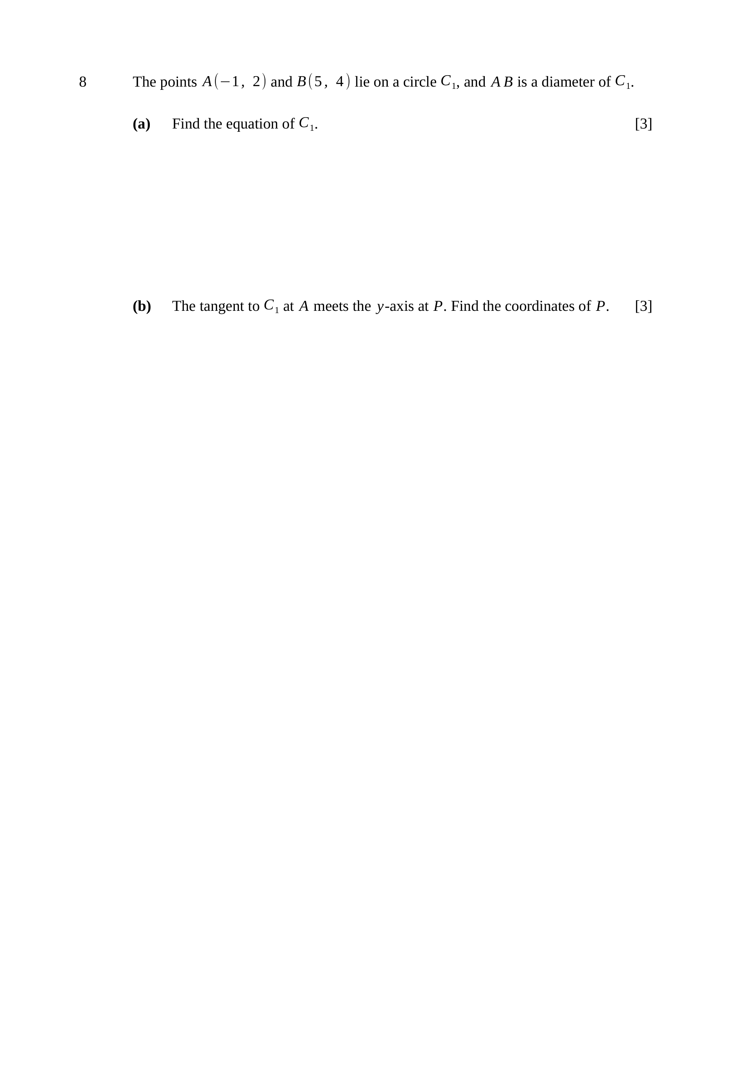
$AB$ a diameter, so the centre is the midpoint of $AB$:
$\text{centre}=\left(\frac{−1+5}{2} , \frac{2+4}{2}\right)=(2, 3)$
$AB^{2}=(5+1)^{2}+(4−2)^{2}=36+4=40$
$\text{radius}=\frac{\sqrt{40}}{2}$, so $r^{2}=10$
$∴(x−2)^{2}+(y−3)^{2}=10$
M1 – centre as the midpoint of the diameter
M1 – $r^{2}=10$ from ${\left(\frac{AB}{2}\right)}^{2}$ or from centre to $A$
A1 – $\left(x−2)^{2}+(y−3)^{2}=10\right.$
gradient of radius $CA=\frac{2−3}{−1−2}=\frac{1}{3}$
tangent $⟂$ radius, so gradient of $\text{tangent}=−3$
at $A(−1, 2)$: $y−2=−3(x+1)$
$y=−3x−1$
at the $y$-axis, $x=0$, so $y=−1$
$∴P(0, −1)$
Key concept: the tangent at a point is perpendicular to the radius there.
M1 – gradient of the $\text{radius}=\frac{1}{3}$
M1 – uses $m_{1}m_{2}=−1$ to get $−3$ and forms the tangent
A1 – $P(0, −1)$

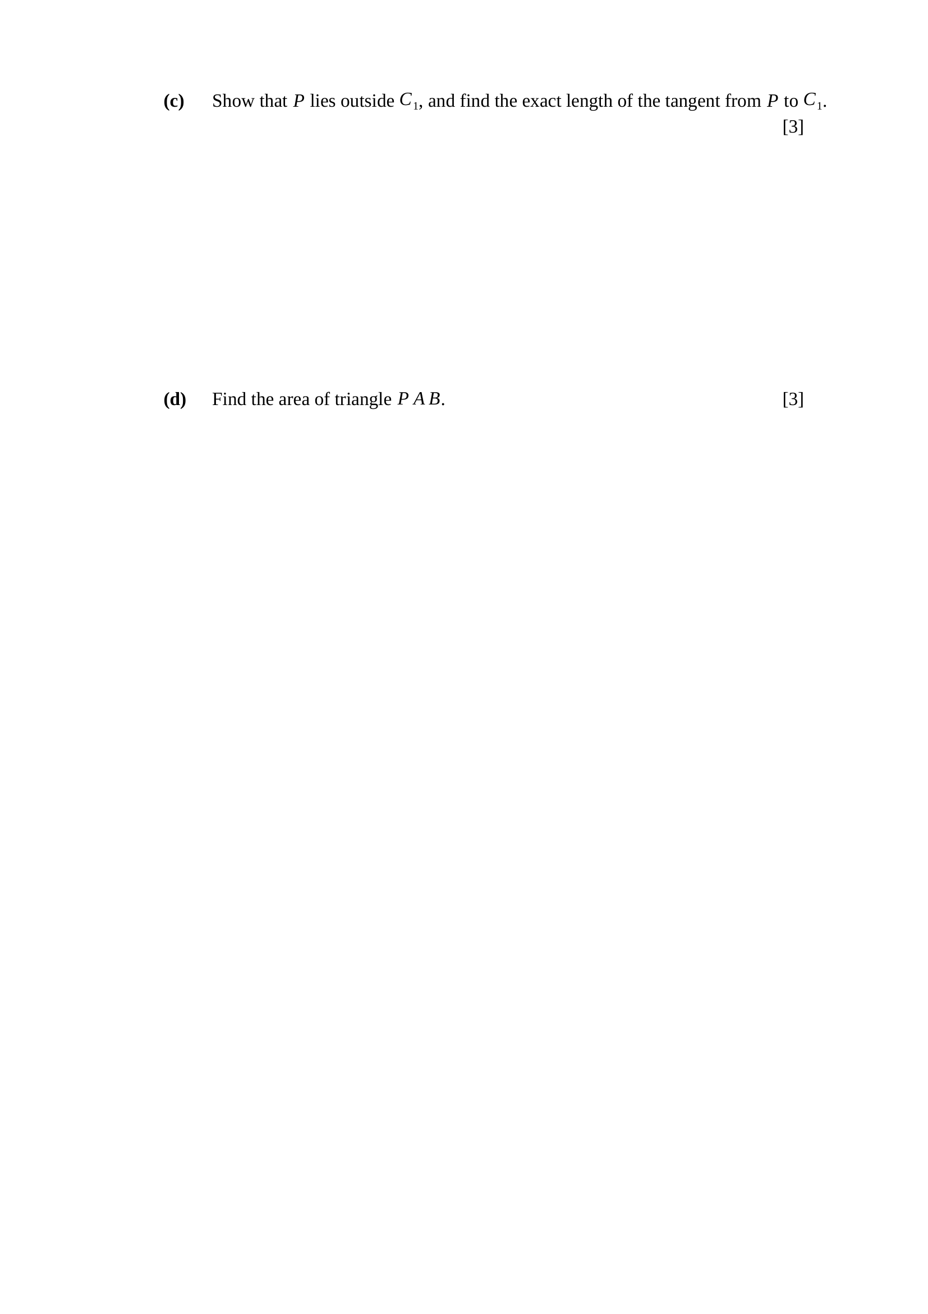
distance from $P(0,−1)$ to the centre $\left(2 , 3\right)$:
$d^{2}=(2−0)^{2}+(3+1)^{2}=4+16=20$
$d^{2}=20>10=r^{2}$, so $P$ lies outside $C_{1}$
tangent $\text{length}=\sqrt{d^{2}−r^{2}}$
$\text{tangent length}=\sqrt{20−10}$
$∴$ tangent $\text{length}=\sqrt{10}$
Key concept: the tangent, the radius and the line to the centre form a right triangle.
M1 – $d^{2}=20$ computed
A1 – compares $d^{2}=20$ with $r^{2}=10$ and concludes $P$ is outside
A1 – $\sqrt{10}$, exact
Trap – comparing $d$ with $r^{2}$, or leaving $\sqrt{10}$ as $3.16$ when EXACT is asked for.
$P(0,−1)$, $A(−1, 2)$, $B(5, 4)$
$\text{area}=\frac{1}{2}\left|x_{P}(y_{A}−y_{B})+x_{A}(y_{B}−y_{P})+x_{B}(y_{P}−y_{A})\right|$
$\text{area}=\frac{1}{2}\left|0(2−4)+(−1)(4+1)+5(−1−2)\right|$
$\text{area}=\frac{1}{2}\left|0 − 5 − 15\right|$
$\text{area}=\frac{1}{2}(20)$
$∴$ $\text{area}=10$ units${}^{2}$
M1 – a correct area method (shoelace, or $\frac{1}{2}×$ base $×$ height)
M1 – correct substitution of all three points
A1 – $10$ units${}^{2}$
Note – $PA⟂AB$ (the tangent), so $\frac{1}{2}(PA)(AB)=\frac{1}{2}\sqrt{10}\sqrt{40}=10$ is a neat check.

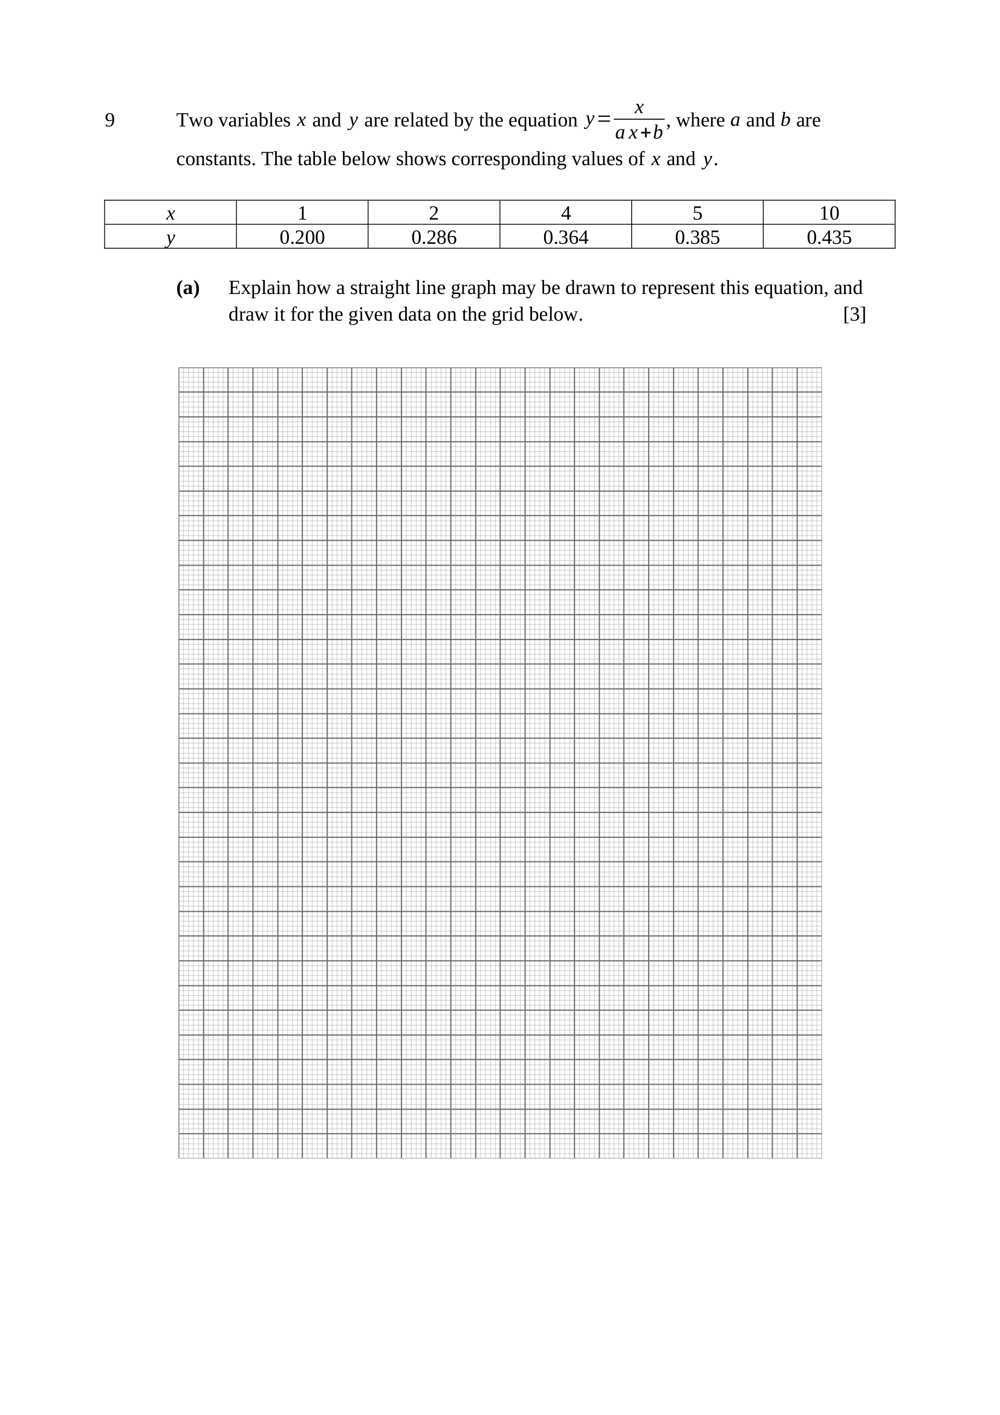
$y=\frac{x}{ax+b}$
taking reciprocals: $\frac{1}{y}=\frac{ax+b}{x}$
$\frac{1}{y}=a+b\left(\frac{1}{x}\right)$
Comparing with $Y=mX+c$: plot $\frac{1}{y}$ against $\frac{1}{x}$;
the graph is a straight line of gradient $b$ and vertical intercept $a$.
$\frac{1}{x}$: $1, 0.5, 0.25, 0.2, 0.1$
$\frac{1}{y}$: $5.00, 3.50, 2.75, 2.60, 2.30$
Key concept: invert BOTH sides first — the linear pair is $\frac{1}{y}$ against $\frac{1}{x}$.
B1 – takes reciprocals to reach $\frac{1}{y}=a+b\left(\frac{1}{x}\right)$
B1 – states: plot $\frac{1}{y}$ against $\frac{1}{x}$, gradient $b$, intercept $a$
B1 – both reciprocal rows computed, points plotted and a straight line drawn
Trap – plotting $y$ against $\frac{1}{x}$, or $\frac{1}{y}$ against $x$, gives a curve.

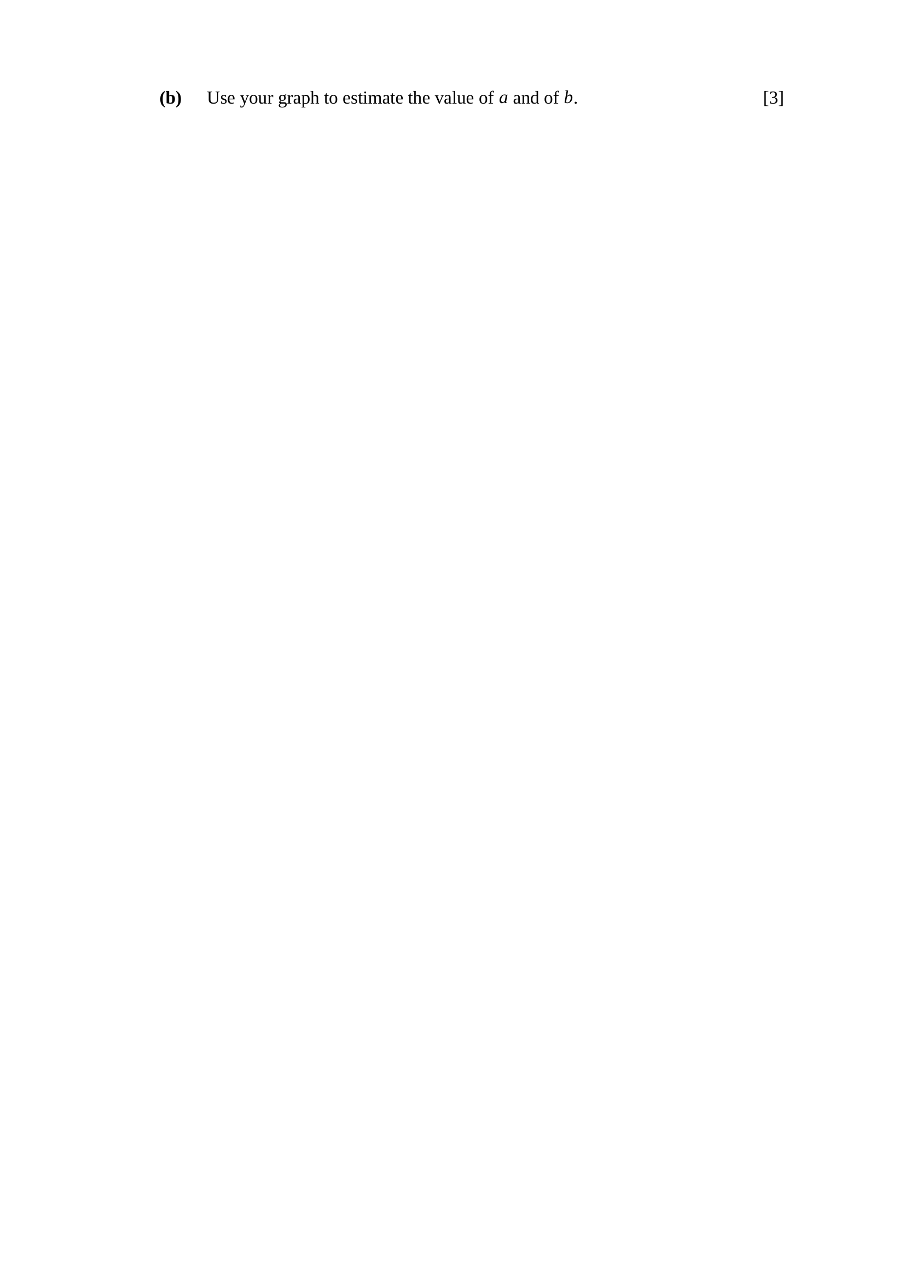
gradient $b=\frac{5.00−2.30}{1.0−0.1}=\frac{2.70}{0.9}$
$b≈3$
intercept: $\frac{1}{y}=a$ when $\frac{1}{x}=0$
$a=5.00−3(1.0)$
$∴a≈2, b≈3$
Key concept: read two points off the DRAWN LINE, as far apart as it allows.
M1 – gradient from two points on the line
A1 – $b≈3$
M1 – intercept read at $\frac{1}{x}=0$, or substitution into the line
A1 – $a≈2$
Note – accept $a$ from $1.8$ to $2.2$ and $b$ from $2.8$ to $3.2$.
Note – check: $y=\frac{x}{2x+3}$ gives $y=0.364$ at $x=4$ ✓

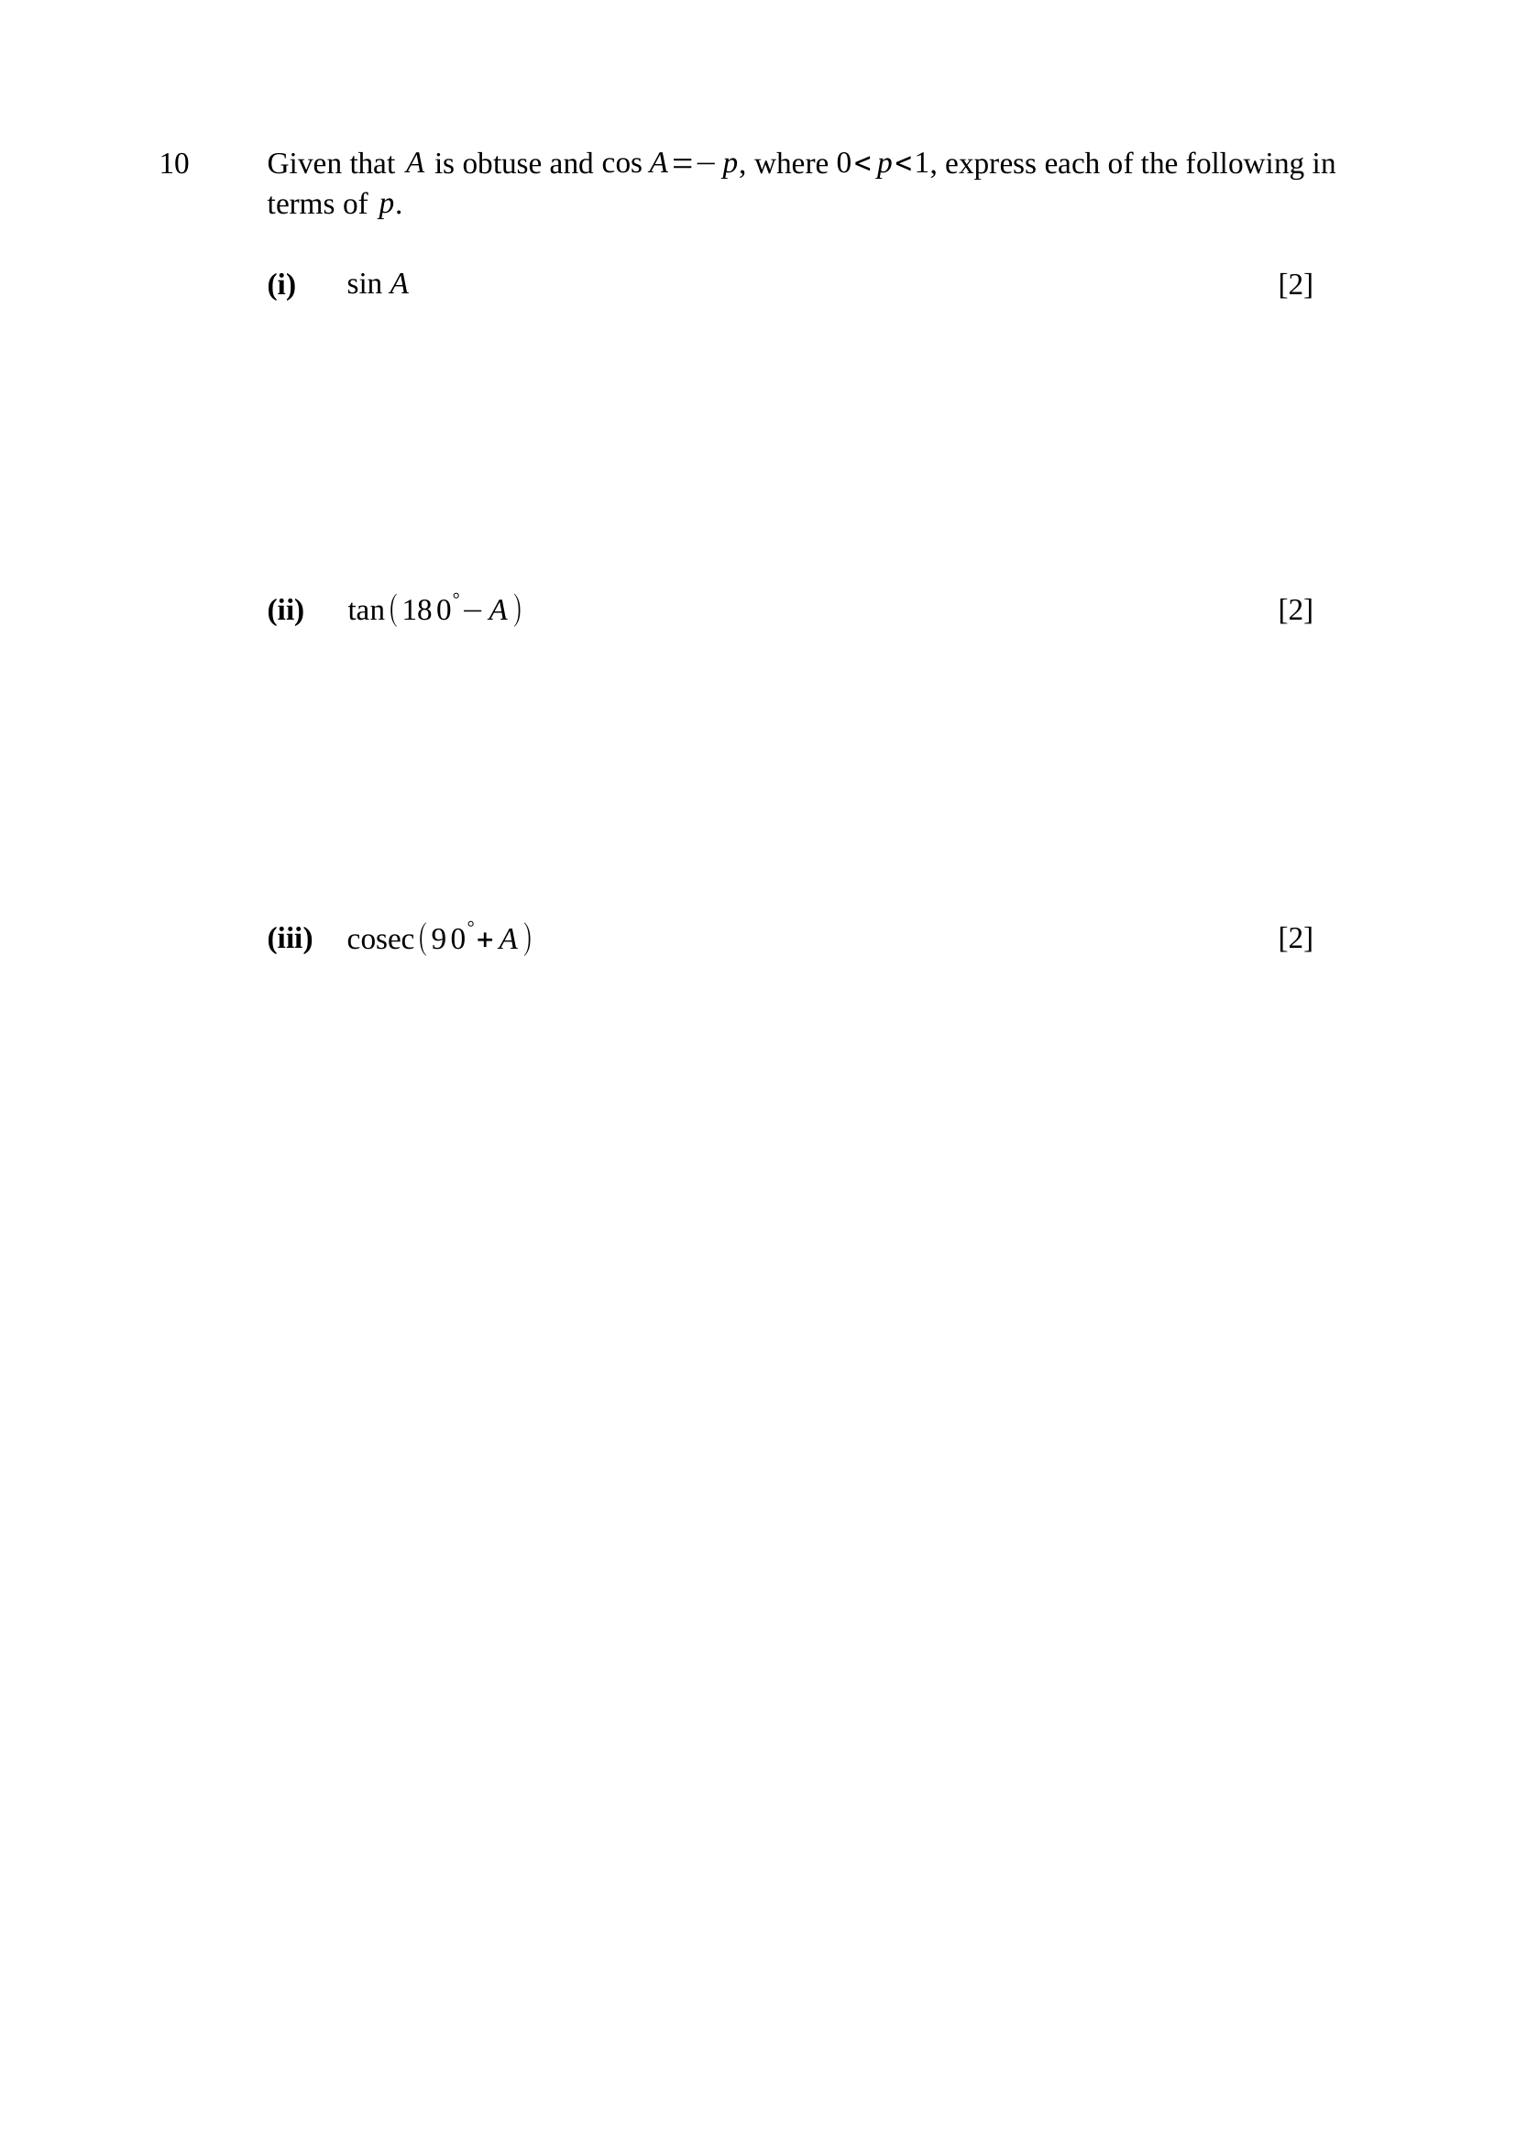
$A$ obtuse, so $A$ is in quadrant 2: $sinA>0$
$\sin^{2}A=1−\cos^{2}A=1−(−p)^{2}=1−p^{2}$
$∴sinA=\sqrt{1−p^{2}}$
M1 – uses $\sin^{2}A+\cos^{2}A=1$
A1 – $\sqrt{1−p^{2}}$, positive because $A$ is obtuse
Trap – $±\sqrt{1−p^{2}}$ loses the A1 — the quadrant decides the sign.
$tan\left({180}^{∘} − A\right)=−tanA$
$tanA=\frac{sinA}{cosA}=\frac{\sqrt{1−p^{2}}}{−p}$
$∴tan\left({180}^{∘} − A\right)=\frac{\sqrt{1−p^{2}}}{p}$
M1 – $tan\left({180}^{∘} − A\right)=−tanA$
A1 – $\frac{\sqrt{1−p^{2}}}{p}$
Note – two negatives cancel: the answer is positive.
$sin\left({90}^{∘} + A\right)=cosA=−p$
$cosec\left({90}^{∘} + A\right)=\frac{1}{sin\left({90}^{∘} + A\right)}$
$∴cosec\left({90}^{∘} + A\right)=−\frac{1}{p}$
M1 – $sin\left({90}^{∘} + A\right)=cosA$
A1 – $−\frac{1}{p}$
Trap – ${90}^{∘}+A$, not ${90}^{∘}−A$: the sine of ${90}^{∘}+A$ is $+cosA$, and $cosA$ is negative here.

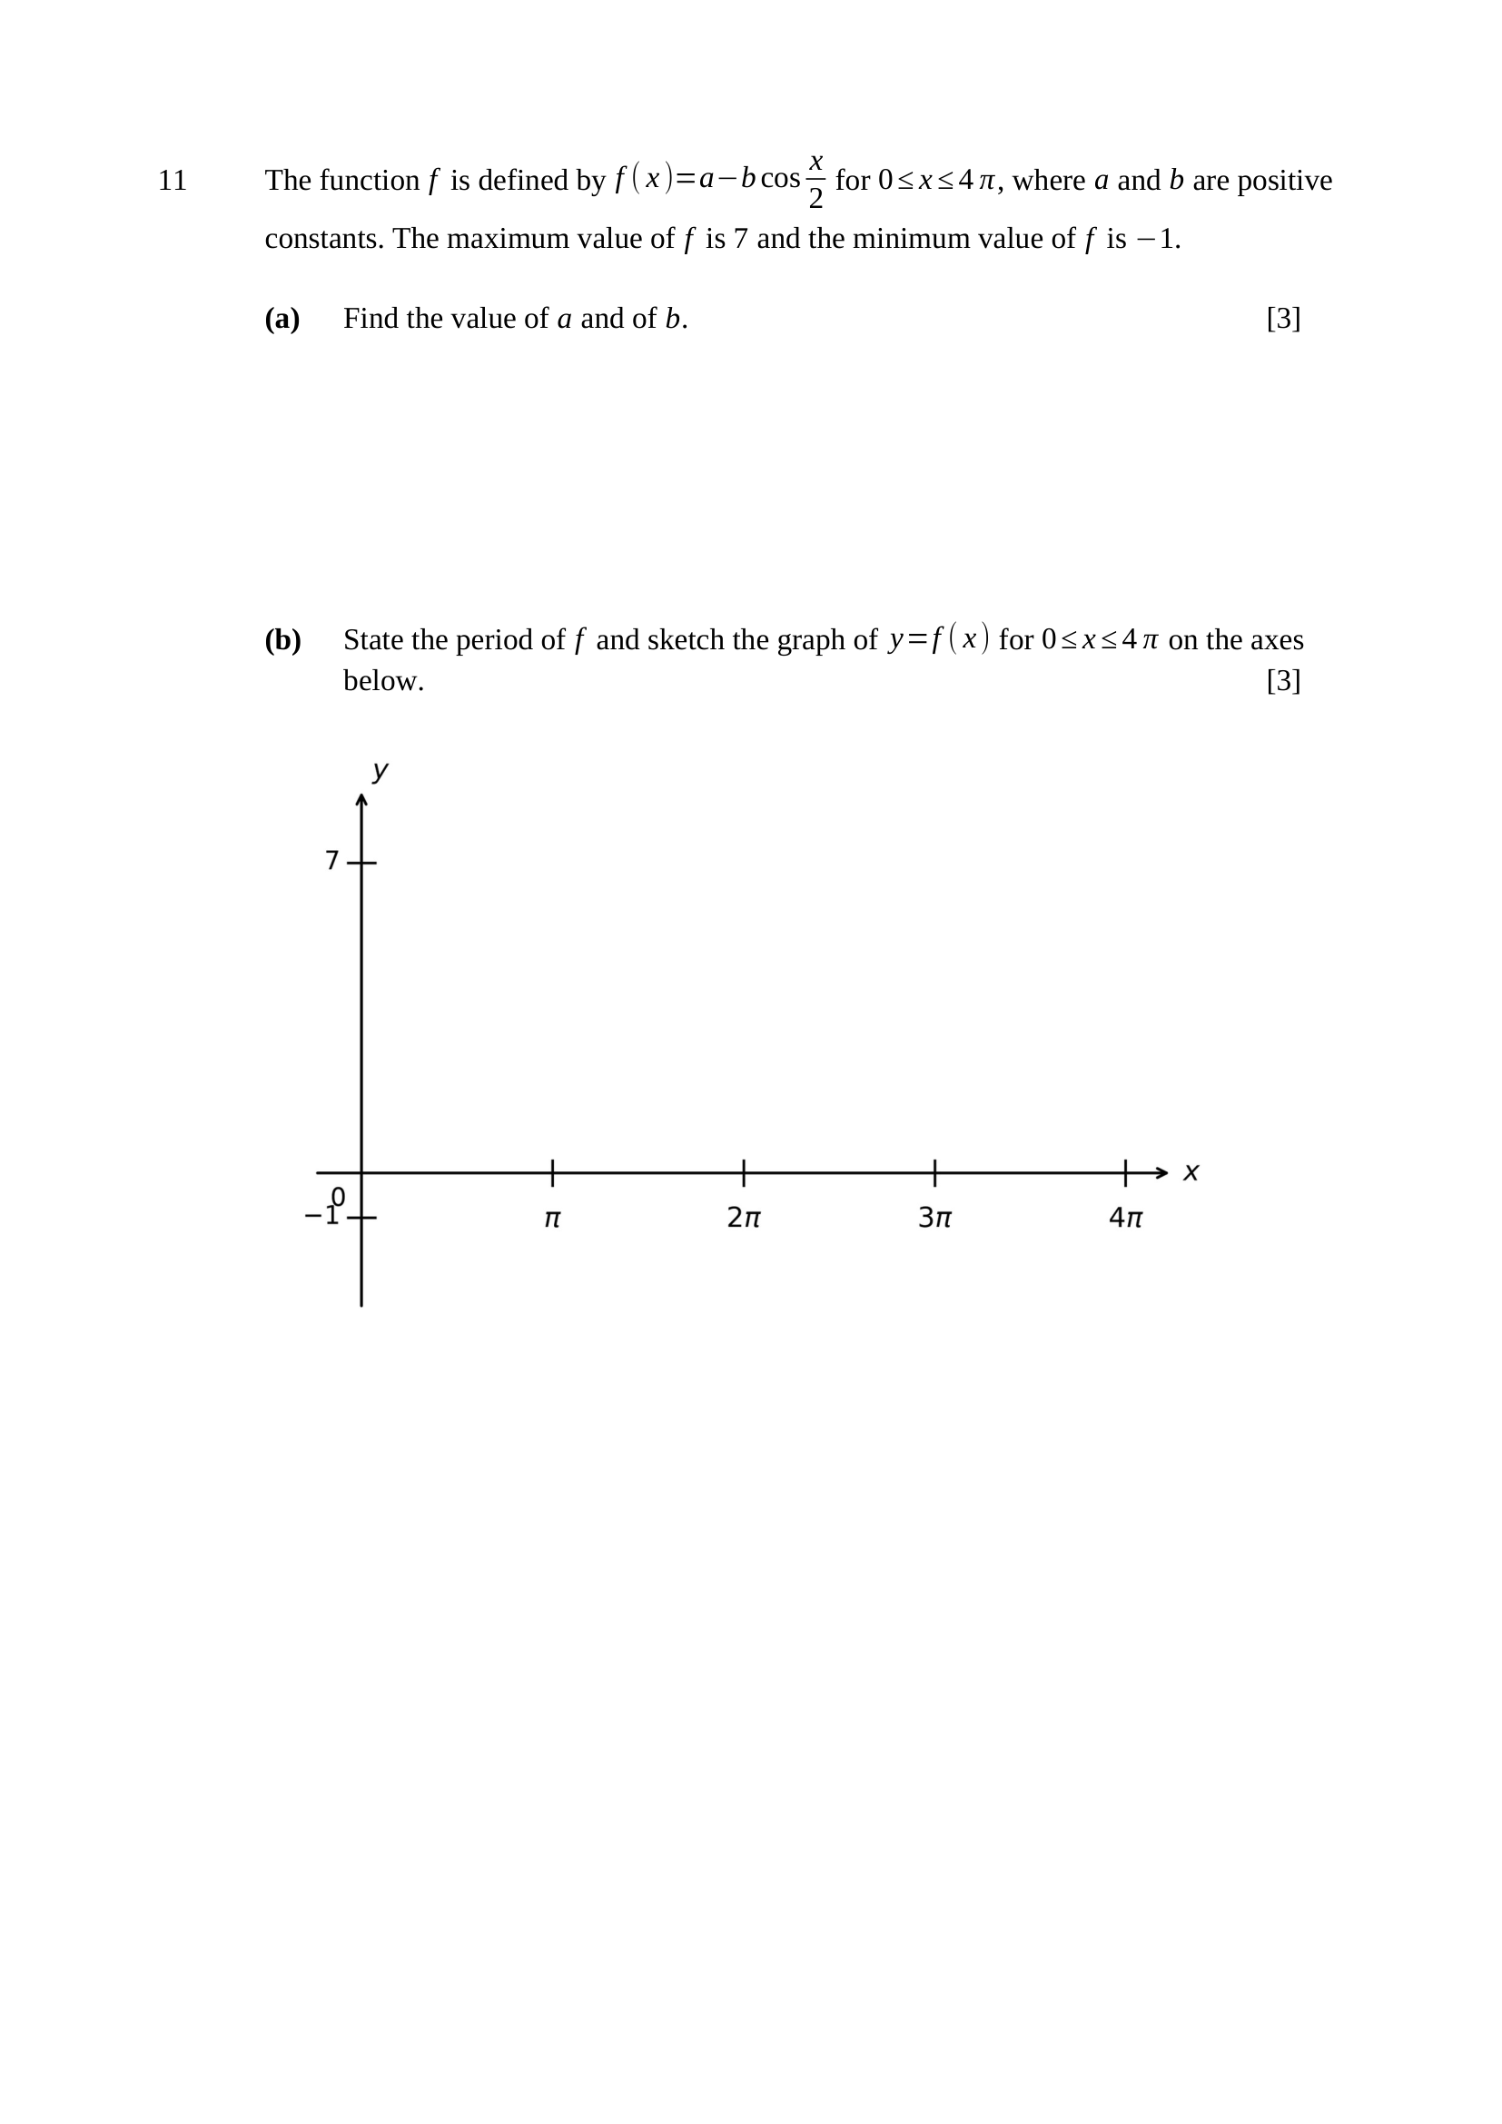
$−cos\frac{x}{2}$ is greatest when $cos\frac{x}{2}=−1$, so $\text{maximum}=a+b=7$
least when $cos\frac{x}{2}=1$, so $\text{minimum}=a−b=−1$
adding: $2a=6$, so $a=3$
$∴a=3, b=4$
Key concept: the minus sign in front of $b$ swaps where the maximum and minimum occur.
M1 – $a+b=7$ and $a−b=−1$ formed
A1 – $a=3$
A1 – $b=4$
Trap – $a−b=7$ comes from ignoring the minus sign in $−bcos\frac{x}{2}$.
$\text{period}=\frac{2π}{\frac{1}{2}}=4π$, so exactly one cycle on $0≤x≤4π$
$f(0)=3−4(1)=−1$ (minimum at $x=0$)
$f(2π)=3−4(−1)=7$ (maximum at $x=2π$)
$f(4π)=−1$; curve crosses $y=3$ at $x=π$ and $x=3π$
B1 – period $4π$
B1 – one complete cycle, starting and ending at the MINIMUM $−1$
B1 – maximum $7$ marked at $x=2π$

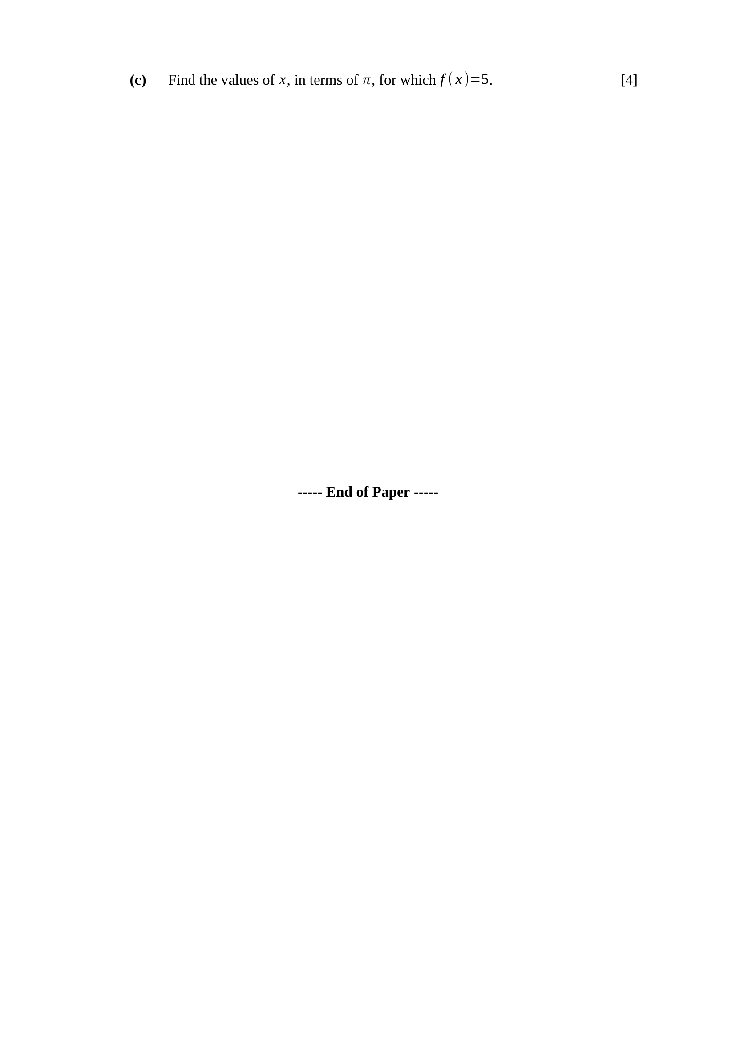
$3−4cos\frac{x}{2}=5$
$−4cos\frac{x}{2}=2$
$cos\frac{x}{2}=−\frac{1}{2}$
$0≤x≤4π$, so $0≤\frac{x}{2}≤2π$
$\text{basic angle}=\frac{π}{3}$; cosine is negative in quadrants 2 and 3
$\frac{x}{2}=π−\frac{π}{3}=\frac{2π}{3}$ or $\frac{x}{2}=π+\frac{π}{3}=\frac{4π}{3}$
$∴x=\frac{4π}{3}$ or $x=\frac{8π}{3}$
Key concept: transform the RANGE as well as the angle — $\frac{x}{2}$ runs to $2π$ only.
M1 – $cos\frac{x}{2}=−\frac{1}{2}$
M1 – converts the range to $0≤\frac{x}{2}≤2π$
A1 – $\frac{x}{2}=\frac{2π}{3}, \frac{4π}{3}$
A1 – $x=\frac{4π}{3}, \frac{8π}{3}$
Trap – working in the original range gives four answers, two of which are outside; doubling must come last.

